**SESSION 2  
Querying FHIR Resources from a HAPI FHIR Server**

**INSTRUCTIONS**

• READ THIS DOCUMENT

• STOP AND EXPLORE CONTENT AT THE EMBEDDED LINKS

• ANSWER THE QUESTIONS AT THE END OF EACH PART

**TABLE OF CONTENTS**

A. WHAT IS A HAPI FHIR SERVER? 2

B. HOW MANY PRACTITIONER RESOURCES ARE IN THE OPEN HAPI FHIR SERVER? 2

C. QUESTIONS 3

D. HOW DO YOU VIEW A FHIR RESOURCE IN THE OPEN HAPI FHIR SERVER? 4

E. QUESTIONS 6

F. HOW DO YOU QUIERY A FHIR RESOURCE USING THE OPEN HAPI FHIR SERVER INTERFACE? 7

G. QUESTIONS 10

H. HOW DO YOU LOGIN TO INTEROPERABILIYLAND? 11

I. WHERE ARE THE HAPI FHIR SERVERS IN THE INTEROPERABILITYLAND PLATFORM? 12

J. HOW DO YOU VIEW THE OAK TREE PHARMACY HAPI FHIR SERVER? 15

K. QUESTIONS 16

### **WHAT IS A HAPI FHIR SERVER?**

A HAPI FHIR Server is a data source available via network built using an open-source library of Java-based software modules. HAPI FHIR Server technology implements HL7 FHIR standards. More information and access to the HAPI FHIR code is here at [hapifhir.io](https://hapifhir.io/). In this Session, we will NOT be implementing a HAPI FHIR Server. Instead, we will use an existing open HAPI FHIR Server for the exercises!

The existing open HAPI FHIR Server that we will use is here: <https://hapi.fhir.org/>

Just as a backup, just in case the link above does not work, here's another link to a HAPI FHIR server that has much less data: <https://hapifhir.openmrs.org/>

### **HOW MANY PRACTITIONER RESOURCES ARE IN THE OPEN HAPI FHIR SERVER?**

To view the number of instances in the Practitioner resource in the open HAPI FHIR Server, follow these steps:

Step 1: Go to <https://hapi.fhir.org/>

Step 2: On left side of the page, scroll down the menu bar to find the Practitioner resource

Step 3: The number on the right side of the resource in the grey bubble indicates the number of instances of the FHIR Practitioner resource currently in this Server (12066):

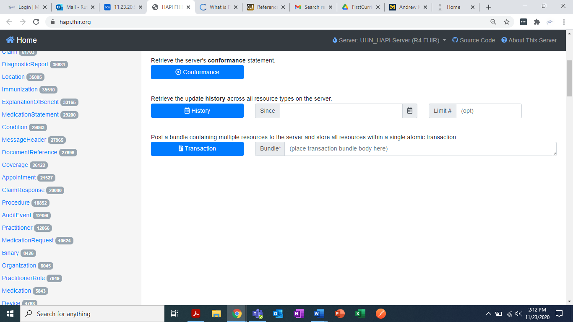

### **QUESTIONS TO TEST YOUR KNOWLEDGE**

How many Patient and Encounter resources can you currently find in the open HAPI FHIR server at <https://hapi.fhir.org/> ?

The Number of Patient FHIR resources is:

**Your answer here**

The Number of Encounter FHIR resources is:

**Your answer here**

### **HOW DO YOU VIEW AN ACTUAL FHIR RESOURCE IN THE OPEN HAPI FHIR SERVER?**

To view an actual Patient FHIR resource in the open HAPI FHIR Server, follow these steps:

Step 1: Go to <https://hapi.fhir.org/>

Step 2: On left side of the page, click on the Patient FHIR resource type to select it:

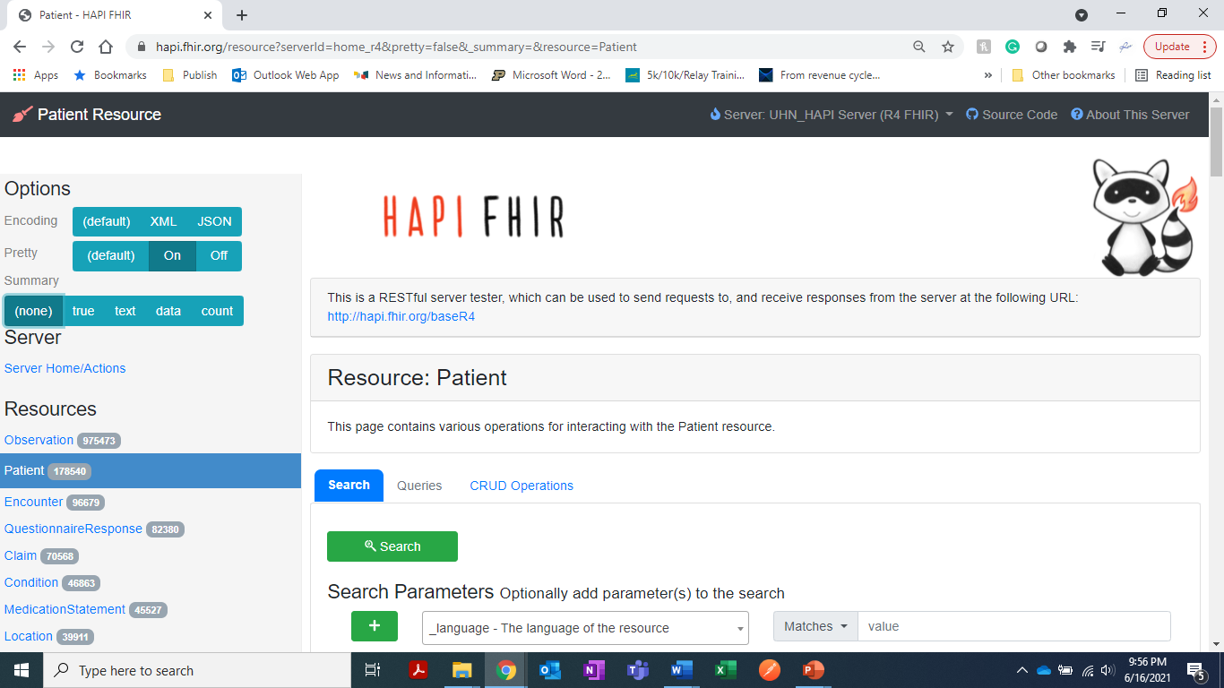

Step 3: With the Patient FHIR resource type selected, click on the green Search button:



Step 4: When you clicked the green Search button, you engaged an API provided by this HAPI FHIR Server. You should now see a list of results appear in the Result Body, like this:

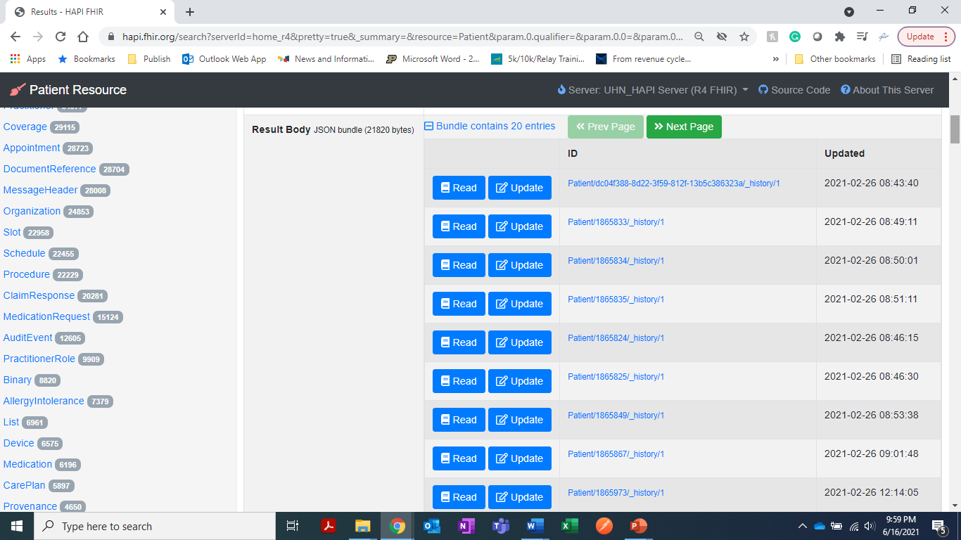

Step 5: Click on the first blue Read button in the list to see a Patient resource. An example of a Patient FHIR resource is the Patient resource for synthetic (i.e., make-believe) patient Brooke Patel in the box below:

{

"resourceType": "Patient",

"id": "1171468",

"meta": {

"versionId": "1",

"lastUpdated": "2020-05-22T12:35:47.178+00:00",

"source": "#qM4DVI9idWWovuJT"

},

"text": {

"status": "generated",

"div": "<div xmlns=\"http://www.w3.org/1999/xhtml\">Brooke Patel</div>"

},

"identifier": [ {

"system": "http://clinfhir.com/fhir/NamingSystem/identifier",

"value": "FHIR_FUN_2020_1"

} ],

"name": [ {

"use": "official",

"text": "Brooke Patel",

"family": "Patel",

"given": [ "Brooke" ]

} ],

"gender": "female",

"birthDate": "2000-05-22"

}

### **QUESTIONS TO TEST YOUR KNOWLEDGE**

* + - 1. What is an example of an Immunization FHIR resource from the open HAPI FHIR Server? To answer, Cut & Paste an example of an Immunization FHIR resource here:

**Your answer here**

* + - 1. What is an example of a Condition FHIR resource from the open HAPI FHIR Server? To answer, Cut & Paste an example of a Condition FHIR resource here:

**Your answer here**

### **HOW DO YOU QUIERY A FHIR RESOURCE USING THE OPEN HAPI FHIR SERVER INTERFACE?**

To perform a query using the open HAPI FHIR server interface, follow these steps:

Step 1: Go to <https://hapi.fhir.org/>

Step 2: On left side of the page, scroll down the menu bar to find the Immunization resource, and click on the Immunization resource:

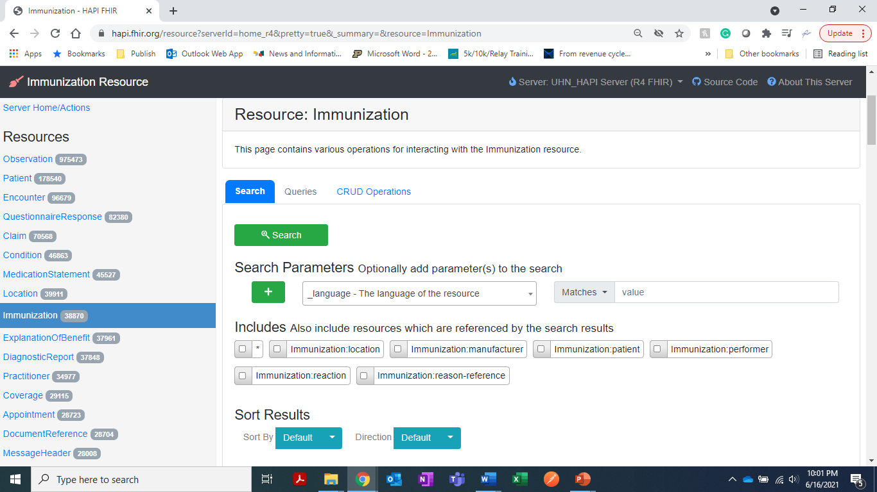

Step 3: Using the Search Parameters drop-down menu to select “reason-code - Reason why the vaccine was administered” from the Search Parameters drop down menu list:

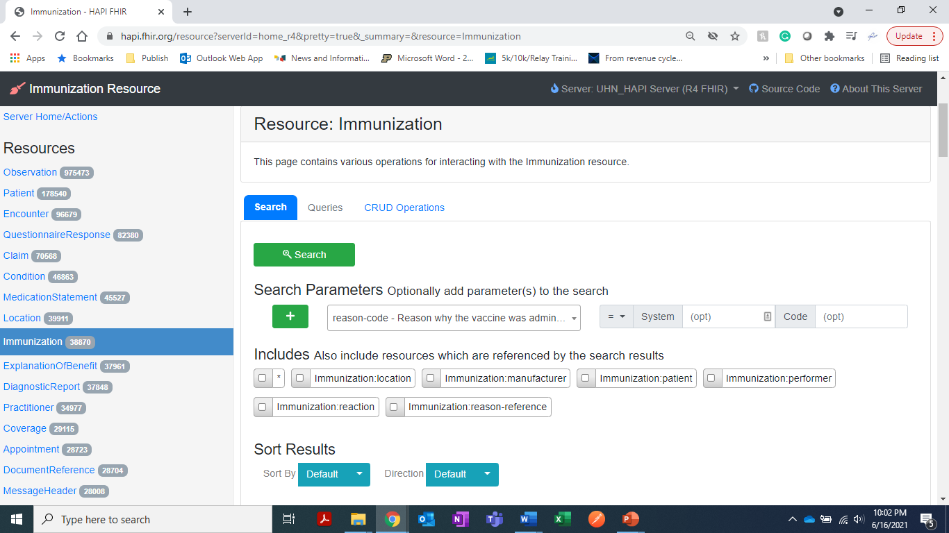

Step 4: Now enter the Code = 429060002 in the Code box on the right:



Step 5: Next, click on the green Search button:



Step 6: What you get is a list of Immunization FHIR resources with the reason-code = 429060002. This reason-code comes from the [SNOMED terminology standard](https://browser.ihtsdotools.org/?perspective=full&conceptId1=429060002&edition=MAIN/2020-07-31&release=&languages=en). It specifies that the immunization was a “Procedure to meet an occupational requirement.” In other words, you have just queried for the subset of the Immunization FHIR resources in the open HAPI FHIR server that were tagged as procedures to meet someone’s work or job requirement!

All the Immunization FHIR resources returned to you from this query have this code. Here’s one example:

{

"resourceType": "Immunization",

"id": "206760",

"meta": {

"versionId": "1",

"lastUpdated": "2019-12-05T05:48:09.585+00:00",

"source": "#DLdqsOCGFnW33lvu"

},

"text": {

"status": "generated",

"div": "<div xmlns=\"http://www.w3.org/1999/xhtml\"><p><b>Generated Narrative with Details</b></p><p><b>id</b>: example</p><p><b>identifier</b>: urn:oid:1.3.6.1.4.1.21367.2005.3.7.1234</p><p><b>status</b>: completed</p><p><b>vaccineCode</b>: Fluvax (Influenza) <span>(Details : {urn:oid:1.2.36.1.2001.1005.17 code 'FLUVAX' = 'Fluvax)</span></p><p><b>patient</b>: <a>Patient/example</a></p><p><b>encounter</b>: <a>Encounter/example</a></p><p><b>occurrence</b>: 10/01/2013</p><p><b>primarySource</b>: true</p><p><b>location</b>: <a>Location/1</a></p><p><b>manufacturer</b>: <a>Organization/hl7</a></p><p><b>lotNumber</b>: AAJN11K</p><p><b>expirationDate</b>: 15/02/2015</p><p><b>site</b>: left arm <span>(Details : {http://terminology.hl7.org/CodeSystem/v3-ActSite code 'LA' = 'left arm', given as 'left arm'})</span></p><p><b>route</b>: Injection, intramuscular <span>(Details : {http://terminology.hl7.org/CodeSystem/v3-RouteOfAdministration code 'IM' = 'Injection, intramuscular', given as 'Injection, intramuscular'})</span></p><p><b>doseQuantity</b>: 5 mg<span> (Details: UCUM code mg = 'mg')</span></p><blockquote><p><b>performer</b></p><p><b>function</b>: Ordering Provider <span>(Details : {http://terminology.hl7.org/CodeSystem/v2-0443 code 'OP' = 'Ordering Provider)</span></p><p><b>actor</b>: <a>Practitioner/example</a></p></blockquote><blockquote><p><b>performer</b></p><p><b>function</b>: Administering Provider <span>(Details : {http://terminology.hl7.org/CodeSystem/v2-0443 code 'AP' = 'Administering Provider)</span></p><p><b>actor</b>: <a>Practitioner/example</a></p></blockquote><p><b>note</b>: Notes on adminstration of vaccine</p><p><b>reasonCode</b>: Procedure to meet occupational requirement <span>(Details : {SNOMED CT code '429060002' = 'Procedure to meet occupational requirement)</span></p><p><b>isSubpotent</b>: true</p><h3>Educations</h3><table><tr><td>-</td><td><b>DocumentType</b></td><td><b>PublicationDate</b></td><td><b>PresentationDate</b></td></tr><tr><td>*</td><td>253088698300010311120702</td><td>02/07/2012</td><td>10/01/2013</td></tr></table><p><b>programEligibility</b>: Not Eligible <span>(Details : {http://terminology.hl7.org/CodeSystem/immunization-program-eligibility code 'ineligible' = 'Not Eligible)</span></p><p><b>fundingSource</b>: Private <span>(Details : {http://terminology.hl7.org/CodeSystem/immunization-funding-source code 'private' = 'Private)</span></p></div>"

},

"identifier": [ {

"system": "urn:ietf:rfc:3986",

"value": "urn:oid:1.3.6.1.4.1.21367.2005.3.7.1234"

} ],

"status": "completed",

"statusReason": {

"coding": [ {

"system": "http://terminology.hl7.org/CodeSystem/v3-ActReason",

"code": "MEDPREC",

"display": "medical precaution"

} ]

},

"vaccineCode": {

"coding": [ {

"system": "urn:oid:1.2.36.1.2001.1005.17",

"code": "FLUVAX"

} ],

"text": "Fluvax (Influenza)"

},

"patient": {

"reference": "Patient/206686"

},

"route": {

"coding": [ {

"system": "http://terminology.hl7.org/CodeSystem/v3-RouteOfAdministration",

"code": "IM",

"display": "Injection, intramuscular"

} ]

},

"doseQuantity": {

"value": 5,

"system": "http://unitsofmeasure.org",

"code": "mg"

},

"note": [ {

"text": "Notes on adminstration of vaccine"

} ],

"reasonCode": [ {

"coding": [ {

"system": "http://snomed.info/sct",

"code": "429060002"

} ]

} ],

"isSubpotent": true,

"subpotentReason": [ {

"coding": [ {

"system": "http://snomed.info/sct",

"code": "429060002"

} ]

} ],

"education": [ {

"documentType": "253088698300010311120702",

"reference": "urn:uuid:53fefa32-fcbb-4ff8-8a92-55ee120877b7",

"publicationDate": "2012-07-02",

"presentationDate": "2013-01-10"

} ],

"programEligibility": [ {

"coding": [ {

"system": "http://terminology.hl7.org/CodeSystem/immunization-program-eligibility",

"code": "ineligible"

} ]

} ],

"fundingSource": {

"coding": [ {

"system": "http://terminology.hl7.org/CodeSystem/immunization-funding-source",

"code": "private"

} ]

},

"reaction": [ {

"date": "2012-01-10",

"reported": true

} ],

"protocolApplied": [ {

"series": "2-dose",

"targetDisease": [ {

"coding": [ {

"system": "http://snomed.info/sct",

"code": "40468003"

} ]

} ],

"doseNumberString": "<string>"

}, {

"series": "3-dose",

"targetDisease": [ {

"coding": [ {

"system": "http://snomed.info/sct",

"code": "66071002"

} ]

} ],

"seriesDosesString": "<string>"

} ]

}

### **QUESTIONS TO TEST YOUR KNOWLEDGE**

* + - 1. Are there any Patient FHIR resources in the open HAPI FHIR Server that contain the given name “Smith”? To answer, go to the Patient resource and search using the parameter “given – A portion of the given name of the Patient” and enter “Smith” into the value field. Do you get any FHIR Patient resources in return?

**Your answer here**

ANSWER: YES or NO?

* + - 1. Are there any Patient FHIR resources in the open HAPI FHIR Server that contain the given name “Ramamoorthi”? To answer, go to the Patient resource and search using the parameter “given – A portion of the given name of the Patient” and enter “Ramamoorthi” into the value field. Do you get any FHIR Patient resources in return?

**Your answer here**

ANSWER: YES or NO?

***Congrats!*** You have just learned how to query a FHIR server using the open HAPI FHIR Server and its user interface search functions!

**Next**, we will begin using a different system that also provides implementations of the HAPI FHIR server software. This new system is called InteroperabilityLand™.

### **HOW DO YOU LOGIN TO INTEROPERABILIYLAND?**

To login to InteroperabilityLand, we can start by following the link to InteroperabilityLand

Step 1: Got to <https://www.interopland.com/login>

Step 2: Login using the provided login credentials provided:

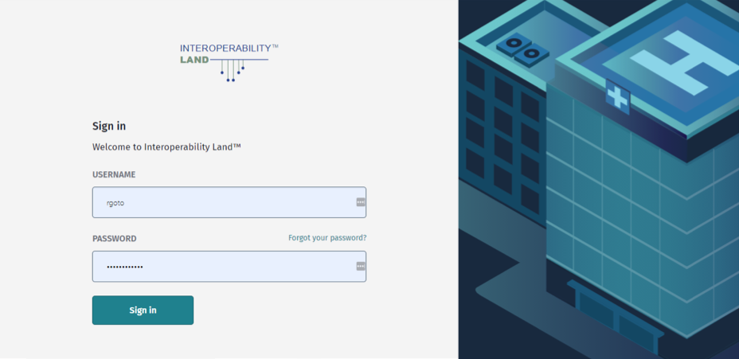

Step 3: If it is your first-time logging in, accept the terms and conditions and set a secure password for yourself to use.

### **WHERE ARE THE HAPI FHIR SERVERS IN THE INTEROPERABILITYLAND PLATFORM?**

Step 1: From the home page, click to open the “Learning Zone 3 Restore” Sandbox:

In the Learning Zone 3 Restore Sandbox, there are 14 synthetic (make-believe) organizations, each one represented by its own name and clickable box (These are the 14 PITs). They look like this:

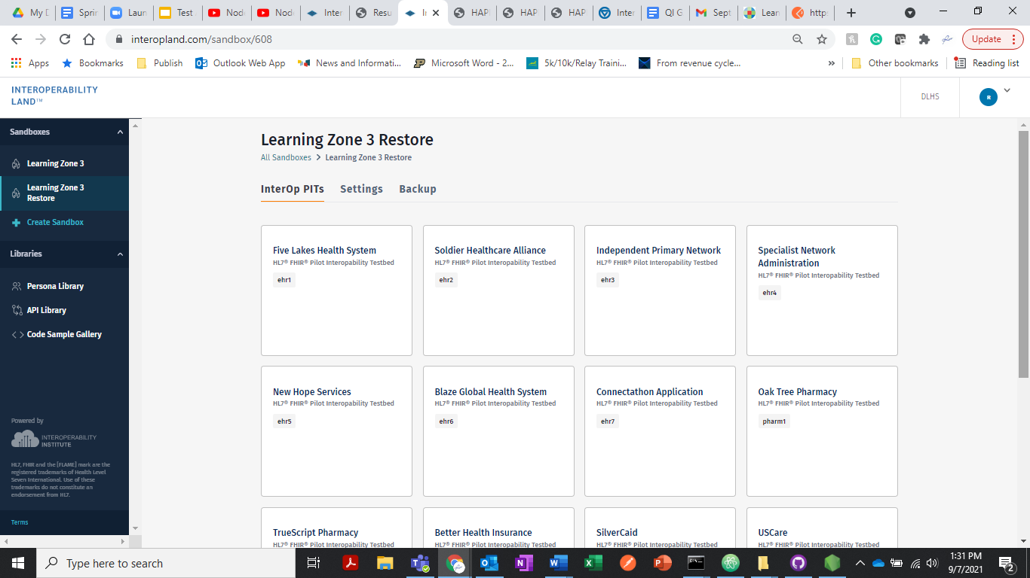

Step 2: Click on the “Five Lakes Health System” box to see its Interop PIT. You will see this:

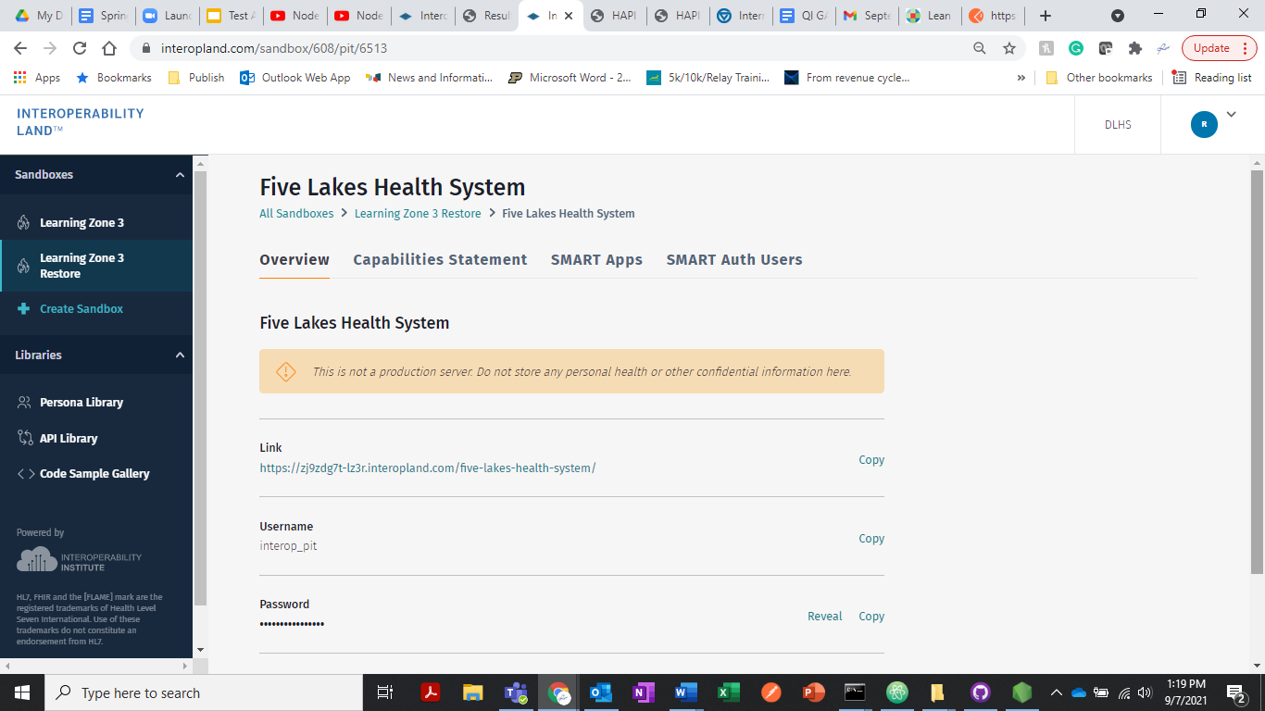

Step 3: Now click on this link in InteroperabilityLand:

<https://zj9zdg7t-lz3r.interopland.com/five-lakes-health-system/>

The link above will take you to another instance of a HAPI FHIR Server!

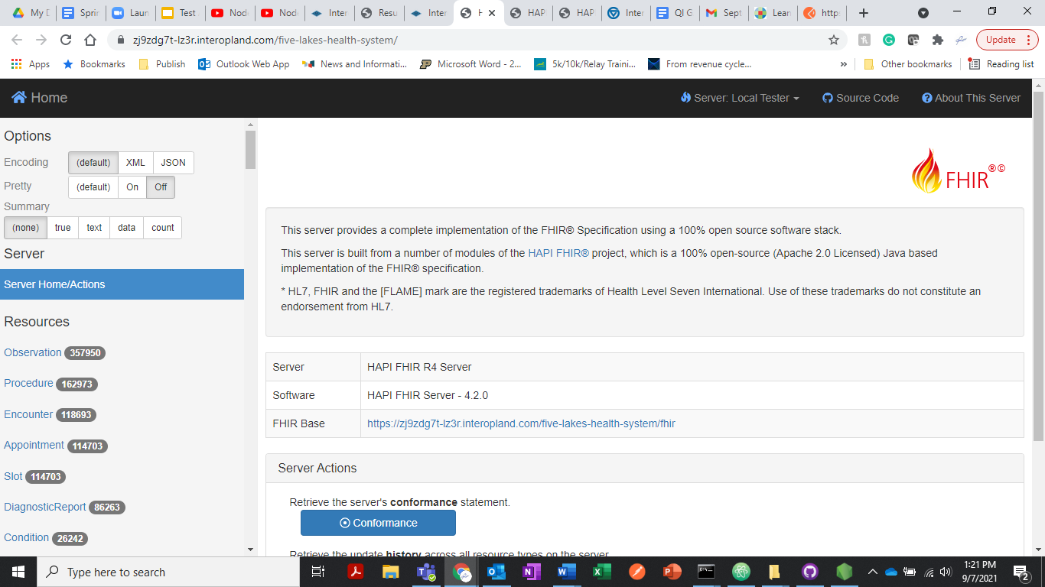

InteroperabilityLand is a FHIR Server test and simulation platform. All 14 InterOp PITS in Learning Zone 3 Restore sandbox (shown above) have links to their own HAPI FHIR Servers with fake or synthetic data. These fake data can be used for testing apps and learning more about FHIR and how it works.

Step 4: Copy the link to the Soldier Healthcare Alliance InterOp Pit HAPI FHIR Server:

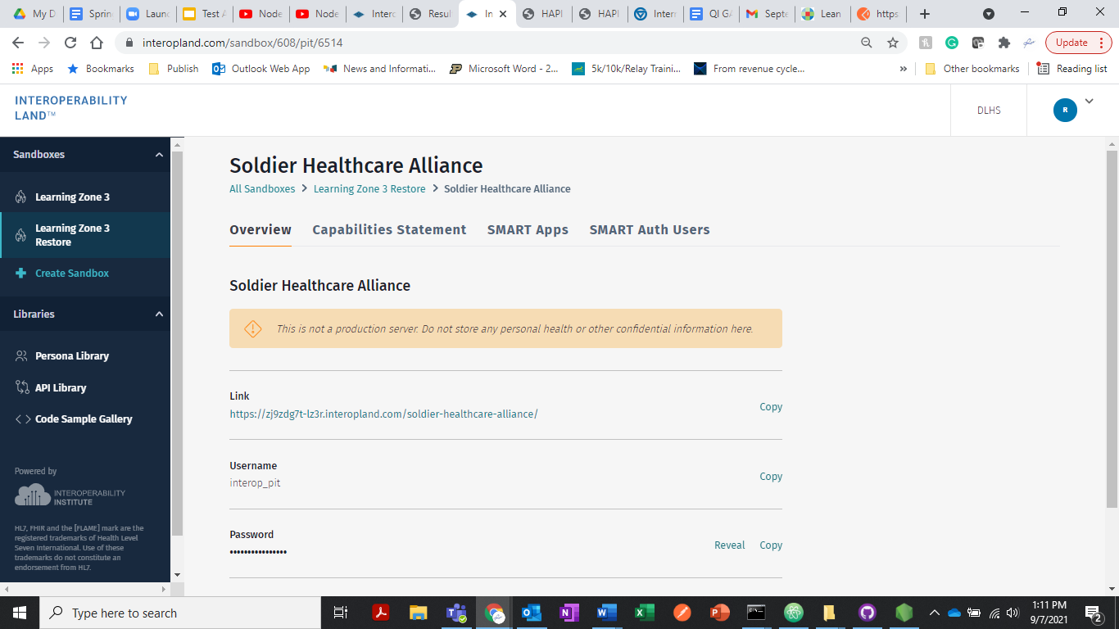

### **HOW DO YOU VIEW OAK TREE PHARMACY HAPI FHIR SERVER?**

To view the Oak Tree Pharmacy HAPI FHIR Server we can use the InteroperabilityLand login page as our starting point (or you can navigate back to the screen with the 14 boxes!)

Step 1: Go to <https://www.interopland.com/login>

Step 2: Login to InteroperabilityLand

Step 3: Open the Learning Zone 3 Restore Sandbox

Step 4: Search for Oak Tree Pharmacy InterOp PIT on the screen with the 14 boxes

Step 5: Open Oak Tree Pharmacy InterOp PIT’s HAPI FHIR server by clicking on the Link

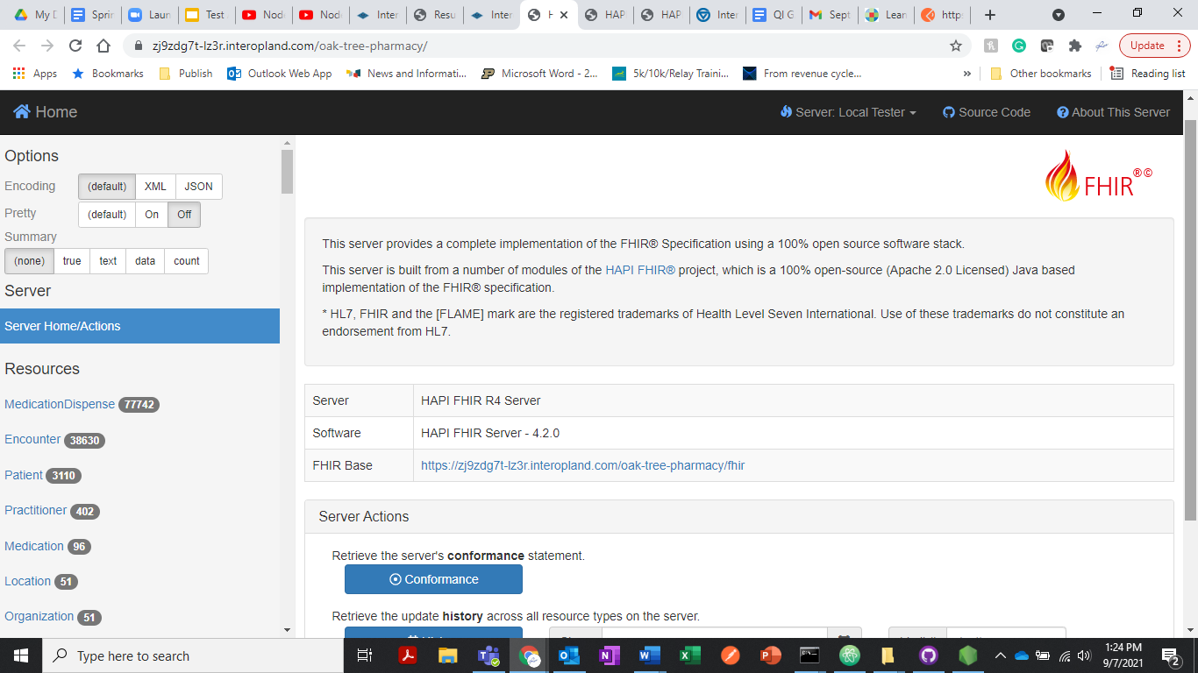

### **QUESTIONS TO TEST YOUR KNOWLEDGE**

* + - 1. How many Patient FHIR resources do you find the HAPI FHIR Server for the SilverCaid InteropPIT in the InteroperabilityLand platform?

**Your answer here**

* + - 1. How many Medication FHIR resources do you find the HAPI FHIR Server for the TrueScript Pharmacy InteropPIT in the InteroperabilityLand platform?

**Your answer here**

* + - 1. Are there any Patient FHIR resources in the HAPI FHIR Server for the Soldier Healthcare Alliance InterOp PIT that contain the given name “Smith”?

**Your answer here**

ANSWER: YES or NO?

* + - 1. Are there any Patient FHIR resources in the HAPI FHIR Server for the MiHIN InterOp PIT that contain the given name “Smith”?

**Your answer here**

ANSWER: YES or NO?

***This is the end of the exercise for Session 2!***

*We encourage you to explore FHIR resources using InteroperabilityLand! This online resource will be available to you through the end of the Introduction to Health Informatics course. If you have a project that would benefit from ongoing access to a synthetic FHIR data platform, let your Instructors know and perhaps additional access to InteroperabilityLand can be arranged.*